 | 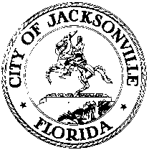
 | OFFICE OF THE CITY COUNCIL
ANNA LOPEZ BROSCHE  PRESIDENT  JACKSONVILLE CITY COUNCIL  OFFICE (904) 630-1452 |  | SUITE 425, CITY HALL  117 WEST DUVAL STREET  JACKSONVILLE, FLORIDA  32202
TASK FORCE ON OPEN GOVERNMENT
AGENDA
June 19, 2018
Don Davis Room
1:00 pm

Introductions

Office of the Attorney General
Pat Gleason, Special Counsel for Open Government

Discussion

Public Comment

Chairs: Hank Coxe and Dr. Sherry Magill
Members: Ywana Allen
Rachael Fortune
The Honorable Alberta Hipps
Ron Littlepage
Michael Lockamy
Audrey Moran
The Honorable Jim Overton
Sabeen Perwaiz
Cleve Warren

The next Task Force Meeting will be Wednesday, June 27, 2018 1:00 pm in the Lynwood
Roberts Room
117 West Duval Street, First Floor

